**Submitted By**

**Group-7 (Team Haraya geche)**

**Shihab Uddin 011221017**

# Table of Content

**Abstract** ....................................................................................................................................................... **4**

**Acknowledgement** .................................................................................................................................... **4**

**CHAPTER 1: Introduction** ....................................................................................................................... **5**

1.1 Purpose .................................................................................................................................... 5

1.2 Problem Statement ................................................................................................................. 5

1.2.1 Problem Background .................................................................................................... 5

1.2.2 Problem Description ...................................................................................................... 5

1.2.3 Problem Reasoning ...................................................................................................... 6

1.3 Goal ........................................................................................................................................... 6

1.4 System Development Life Cycle (SDLC) ............................................................................. 7

**CHAPTER 2: System Study or Information Gathering** .................................................................... **8**

2.1 Introduction .............................................................................................................................. 8

2.2 Information Sources ................................................................................................................ 8

2.2.1 Internal Sources ................................................................................................................... 8

2.2.2 External Sources ........................................................................................................... 8

2.3 Information Gathering ............................................................................................................. 9

2.3.1 Internal Sources ............................................................................................................ 9

2.3.2 External Sources ........................................................................................................... 9

2.5 Research Papers .................................................................................................................. 10

2.6 Similar Websites .................................................................................................................... 12 Food Panda............................................................................................................................ 12

Zomato .................................................................................................................................... 12

Talabat .................................................................................................................................... 12

TED ................................................................................................................................................ 13

2.7 Define and Desired State ..................................................................................................... 14

Define (Current State) ................................................................................................................. 14

Desired State ................................................................................................................................ 14

**CHAPTER 3: System Analysis** ............................................................................................................ **14**

3.1 Introduction ............................................................................................................................ 14

3.2 Gap Analysis .......................................................................................................................... 15

Targeted Gap Analysis: What Others Lack That ELMSOffers ..................... 15

3.3 Benchmark ............................................................................................................................. 16

3.4 Survey ..................................................................................................................................... 17

3.4.1 Survey Methodology ................................................................................................... 17

3.4.2 Survey Results and Analysis ..................................................................................... 18

3.4.3 Some Reviews On Our Survey ................................................................................. 25

3.5 SWOT ANALYSIS ................................................................................................................. 26 **Chapter - 4: Design of the System** ..................................................................................................... **28**

4.1 Introduction ............................................................................................................................ 28

4.2 Context Diagram ................................................................................................................... 28

4.3 Use-Case Diagram ............................................................................................................... 29

A Use-Case Diagram depicts the interactions between users and the system. It helps to

understand the high-level functionality of the system ............................................................. 29

4.3.1 USE CASE Description .............................................................................................. 30 Use-Case ID: UC-001 .................................................................................................... 30

Use-Case ID: UC-002 .................................................................................................... 32

Use-Case ID: UC-003 .................................................................................................... 33

Use-Case ID: UC-004 .................................................................................................... 34

4.4 Use-Case Description ........................................................................................................... 37

○ Post-condition: Users can visualize their growth and areas of improvement .................. 37

4.5 Class Diagram ....................................................................................................................... 37

4.6 Sequence Diagram ............................................................................................................... 38

The Sequence Diagram illustrates how objects interact in a sequence over time ............. 38

4.7 Activity Diagram .................................................................................................................... 40

4.8 SwimLane Diagram .............................................................................................................. 41

4.10 Deployment Diagram .......................................................................................................... 41

4.11 CRC Diagram ...................................................................................................................... 42

4.12 State Diagram ..................................................................................................................... 43

4.13 Schema Diagram:definition .............................................................................................. 44

A schema diagram is a visual representation of the logical structure of a database ......... 44

**Chapter - 5: Prototype or UI Design** ................................................................................................... **45**

5.1 Introduction ............................................................................................................................ 45

5.2 Prototyping Tools Used ........................................................................................................ 45

5.3 UI Design ................................................................................................................................ 45

Mandel’s Golden Rules

The golden rules are divided into three groups ................................................................ 45

Place Users in Control .......................................................................................................... 46

Reduce Users’ Memory Load .............................................................................................. 46

5.3.1 Color Palette ....................................................................................................................... 47

5.3.2 Typography ......................................................................................................................... 47 5.3.3 Layout .................................................................................................................................. 47 5.3.4 Key Features ...................................................................................................................... 47

5.4 Sitemap .................................................................................................................................. 47

5.4.1 Overview of Sitemap ................................................................................................... 48

5.4.2 Navigation Flow ........................................................................................................... 52

Conclusion ........................................................................................................................................... 52

# Abstract

**ELMS (Educational Learning Management System)** is a secure, web-based platform revolutionizing academic administration, teaching, and learning. Built with JWT authentication, RBAC, and Socket.IO real-time communication, it serves administrators, teachers, and students seamlessly.

The **Admin Dashboard** handles user/course management, enrollments, analytics, and events. **Teachers** upload materials (PDF/DOC/PPT/video), create auto-calendared assignments, grade with feedback, and chat in real-time. **Students** enroll in courses, submit/resubmit assignments, view grades, access calendars, and use an **AI Learning Assistant** via Open Router for personalized help.

Features include file validation, notifications, search/filtering, and analytics.

# Acknowledgement

We extend our sincere appreciation to everyone who contributed to the development of ELMS—a project built to simplify and enhance the study experience for the UIU community. Designed to centralize all the feature of ELMS in one place and make it more useful.

Our heartfelt thanks go to our mentors for their continuous guidance, to our peers for their collaboration and encouragement, and to all the students who participated in our survey and testing phases—your feedback was invaluable. We are also grateful for the tools, technologies, and learning platforms that empowered us to bring this idea to life.

ELMSstands as a reflection of shared effort and dedication. We hope it proves to be a practical and impactful solution for students and staff alike.

Sincerely,

Team Haraya geche

# CHAPTER 1: Introduction

**1.1 Purpose:**

The purpose of this project is to create an **E-Learning Management System (ELMS)** that helps manage learning activities online. The system connects **students, teachers, and admins** in one platform.

Admins can create courses, sections, and teacher accounts. Teachers can upload course materials and give assignments, while students can view materials, submit assignments, and chat with others in the same section.

The system also includes an **AI chatbot** to help users and a **calendar** to organize academic events and deadlines.

The main goal of this project is to make learning easier, faster, and more organized for everyone involved.

.

.

1.2 Problem Statement:

1.2.1 Problem Background:

With the increasing use of digital platforms in education, **Learning Management Systems (LMS)** have become vital for managing courses, materials, and communication between teachers and students. These systems are designed to make learning more accessible, organized, and interactive.

However, in many universities, including ours, the existing LMS faces several challenges that affect user experience and learning efficiency. The **navigation system is complex**, making it difficult for students and teachers to find courses, assignments, or announcements easily. This lack of intuitive design reduces productivity and often leads to frustration.

Another major issue is the **calendar and event management feature**, which does not allow users to view all important dates and events on a single page. This limitation creates confusion when tracking assignment deadlines, examinations, and other academic activities.

As the demand for online and blended learning continues to grow, it has become necessary to design a more **user-friendly and interactive E-Learning Management System (ELMS)** that addresses these limitations and provides a seamless learning experience for all users.

**1.2.2 Problem Description:**

In the existing Learning Management System (LMS) used at our university, several usability and functionality issues have been identified that affect both students and teachers in their daily academic activities.

One of the major problems is the **complex navigation structure**, which makes it difficult for users to find essential features such as course materials, assignments, and announcements quickly. This lack of an intuitive interface leads to confusion, reduced productivity, and a poor user experience.

Another significant issue is the **calendar feature**, which is not user-friendly and does not display all dates and events on the same page. As a result, users face challenges in tracking upcoming assignments, exams, and academic events efficiently.

Furthermore, the current system lacks **interactive and modern features** such as real-time communication tools, AI-based assistance, and efficient section-based collaboration. These limitations hinder smooth communication between students and teachers and reduce engagement in online learning.

Therefore, there is a need for a more **organized, interactive, and user-friendly E-Learning Management System (ELMS)** that simplifies navigation, improves calendar usability, and enhances communication and learning efficiency for all users.

**1.2.3 Problem Reasoning:**

Here’s why the current challenges with our university’s Learning Management System (LMS) exist — and why they need to be addressed:

1. **Complex and Unintuitive Navigation**  
   ○ The current LMS has a cluttered and confusing interface, making it difficult for students and teachers to find courses, assignments, or study materials quickly.  
   ○ This results in wasted time, lower productivity, and frustration among users who need an intuitive and well-organized system.
2. **Inefficient Calendar and Event Management**  
   ○ The existing calendar does not display all dates and events on one page, making it hard for students to keep track of deadlines, classes, and activities.  
   ○ As a result, important assignments or exams may be overlooked, affecting students’ academic performance.
3. **Limited Interaction and Communication Tools**  
   ○ There is no dedicated space for real-time discussion or collaboration within a section.  
   ○ Without chat rooms or messaging features, communication between teachers and students remains slow and less engaging.
4. **Lack of Intelligent Assistance and Automation**  
   ○ The current system does not offer AI-based support to help users quickly find information, solve issues, or get guidance on using the platform.  
   ○ This increases dependency on manual help and makes the system less efficient.
5. **Absence of Modern Learning Features**  
   ○ Students and teachers cannot easily upload, share, or access digital learning materials in a seamless way.  
   ○ Missing features like instant assignment submission, automated notifications, and event reminders make learning less interactive and organized.

The **E-Learning Management System (ELMS)** is designed to solve these problems by introducing a **modern, user-friendly, and intelligent learning platform**. It will simplify navigation, provide a visual and interactive calendar, enable real-time communication, and integrate AI assistance — creating a smarter, faster, and more connected digital learning experience for everyone.

**1.3 Goal:**

The goal of the **E-Learning Management System (ELMS)** is to modernize and streamline the learning experience for students, teachers, and administrators within the university.  
Here’s how it aims to achieve that:

● **Simplify Academic Access**  
Provide a centralized platform where students and teachers can easily access courses, materials, assignments, and announcements in one place.

● **Enhance Communication & Collaboration**  
Enable real-time communication through section-based chat rooms, allowing students and teachers to discuss topics, share ideas, and collaborate effectively.

● **Improve Teaching & Learning Efficiency**  
Allow teachers to upload and manage course materials, assignments, and assessments, while students can easily view and submit their work online.

● **Enable Smart Academic Management**  
Equip administrators with powerful tools to manage users, create courses, assign teachers, and monitor academic progress efficiently.

● **Integrate AI Assistance**  
Include an AI-powered chatbot to help users navigate the system, find information, and get instant support, reducing confusion and manual dependency.

● **Streamline Event & Deadline Tracking**  
Introduce an interactive calendar feature that displays all events, deadlines, and academic schedules in one view for better organization.

By combining all these features, **ELMS** aims to create a smarter, more connected, and efficient digital learning environment — enhancing accessibility, communication, and productivity across the entire academic community.

**1.4 System Development Life Cycle (SDLC):**

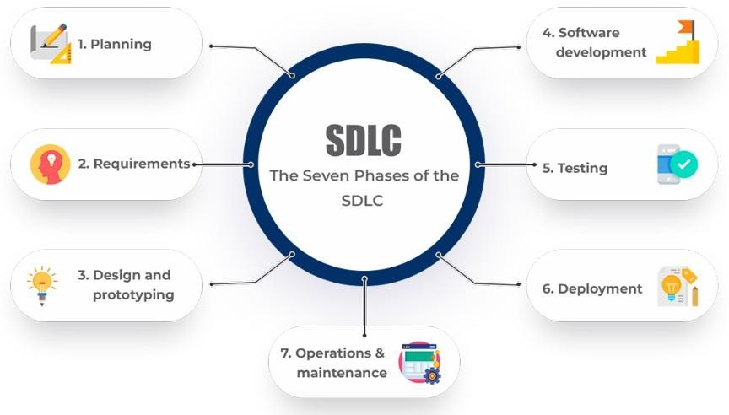

To make sure Project ELMS delivers on its promise, we’re following a structured plan called the Software Development Life Cycle. Here’s how it works:

1. **Planning**:

1. ○ **Defining Clear Objectives**  
   ○ Establishing the main goals of the ELMS — such as improving accessibility, simplifying academic management, and enhancing communication between students, teachers, and admins.
2. **Understanding User Needs**  
   ○ Conducting surveys or discussions with students, teachers, and administrators to identify pain points in the current LMS and define what features are most important.
3. **Setting Project Scope & Deliverables**  
   ○ Clearly outlining what the system will include — such as authentication, course management, AI chatbot, chat rooms, calendar, and assignment submission — and what will be excluded.
4. **Creating a Development Timeline**  
   ○ Dividing the project into key phases (requirement analysis, design, development, testing, and deployment) with specific deadlines and responsibilities.
5. **Resource Allocation**  
   ○ Assigning roles to team members, such as front-end design, back-end development, database management, and testing, to ensure efficient workflow.
6. **Risk Assessment & Backup Planning**  
   ○ Identifying possible challenges (e.g., system bugs, data errors, or integration issues) and preparing strategies to minimize delays and risks.
7. **Documentation & Progress Tracking**  
   ○ Maintaining clear documentation throughout each stage and tracking progress to ensure the project stays aligned with its objectives and timeline.

This planning process ensures that **Project ELMS** starts with a clear vision, stays organized, and delivers a reliable, user-friendly learning platform that meets the real needs of its users.

CHAPTER 2: System Study or Information Gathering

**2.1 Introduction:**

**2.2** The effectiveness of **ELMS** lies in its unified approach to enhancing the digital learning experience on campus. With features such as **role-based authentication, course and section management, AI chatbot assistance, chat rooms, assignment submission, material uploads, and an interactive calendar**, it offers a complete solution for academic management at the university.

By focusing on **user convenience, role-specific functionality, and seamless interaction**, ELMS ensures faster access to course materials, better communication between students and teachers, and organized tracking of academic events and deadlines. The system supports the diverse needs of **students, teachers, and administrators**, improving engagement, collaboration, and overall efficiency within the learning environment.

## 2.2.1 Internal Sources

Internal sources of information form the core of **ELMS**, enabling the system to deliver a personalized and efficient learning experience. These include:

● **User Inputs:** Information such as login credentials, profile details, course enrollments, and assignment submissions helps tailor the system to each user and streamline their experience.

● **System Interactions:** Data generated from user actions—like accessing course materials, submitting assignments, participating in chat rooms, and using the calendar—enables the platform to improve functionality, responsiveness, and overall user experience over time.

● **Admin & Teacher Logs:** Activity records from administrators and teachers (e.g., course creation, section management, material uploads, assignment grading) help monitor academic management and operational efficiency.

● **Feedback and Testing:** Insights gathered during the development phase through surveys, testing sessions, and real-time usage analytics are used to refine features and enhance usability for all user roles.

### 2.2.2 External Sources

External sources contribute additional support and insight to improve the performance, reliability, and user experience of **ELMS**. These include:

● **Benchmark Platforms:** Inspiration and reference are taken from popular learning management systems and educational platforms (e.g., Moodle, Google Classroom, Canvas), helping to align ELMS with modern usability and academic standards.

● **Open-Source Tools and Libraries:** Utilization of frontend and backend frameworks, UI templates, and JavaScript/React libraries supports fast, secure, and scalable development.

● **Feedback from Similar Institutions:** Observations and data from other university or campus-based LMS platforms provide valuable insights to refine design, workflows, and features tailored to educational environments.

## 2.3 Information Gathering

### 2.3.1 Internal Sources

Internal sources play a critical role in shaping the structure and efficiency of **ELMS**, drawing from user-generated and system-captured data to continuously enhance the platform:

1. **User Inputs:**  
   ○ Login data, user profiles, course enrollments, and assignment submissions allow the system to provide a more personalized and organized learning experience.  
   ○ User-submitted feedback helps identify bugs, suggest new features, and improve usability across the platform.
2. **System Usage Data:**  
   ○ Analytics from course access, material downloads, assignment submissions, chat room participation, and calendar usage reveal usage patterns that inform UX improvements and performance optimization.  
   ○ Most-accessed courses, frequently visited sections, and active discussion threads guide decisions on feature prioritization and system enhancements.
3. **Pilot Testing and Feedback:**  
   ○ Early testing with students, teachers, and administrators provided direct insights into pain points and improvements needed in real-world scenarios.  
   ○ Beta feedback helped adjust navigation flow, course material management, chat room functionality, assignment handling, and calendar features to better align with user expectations and academic operations.

### 2.3.2 External Sources

External sources complement internal data by providing expert insights, reliable resources, and foundational knowledge to create a robust and versatile platform.

1. **In-field Suvey:**

○ We have done in field survey to know what really students like to prefer. Based on the survey we made the project.

**2.5 Research Papers :**

## 2.6 Similar Websites

How industry leaders in digital learning can inform **ELMS’s** design and functionality:

1. **Moodle**  
   • **Strengths:** Highly customizable, supports multiple course formats, robust assessment tools.  
   • **UIU Adaptation:**  
   ○ **Simplified Interface:** Streamline navigation for students and teachers to reduce complexity.  
   ○ **Course Templates:** Pre-designed course structures for faster setup by admins and teachers.
2. **Google Classroom**  
   • **Strengths:** Easy assignment submission, integrated calendar, strong collaboration features.  
   • **UIU Adaptation:**  
   ○ **Section-Based Chat Rooms:** Allow students to interact with peers in the same section.  
   ○ **Interactive Calendar:** Display all academic events and deadlines on a single, user-friendly page.
3. **Canvas**  
   • **Strengths:** Modern UI, mobile-friendly, AI-supported analytics, and communication tools.  
   • **UIU Adaptation:**  
   ○ **AI Chatbot Assistance:** Provide instant guidance and support for system usage.  
   ○ **Analytics Dashboard:** Allow admins and teachers to track student engagement and performance efficiently.

By benchmarking these platforms, **ELMS** can adopt best practices while tailoring features to the **unique needs of UIU students, teachers, and administrators**, ensuring a more organized, interactive, and efficient learning environment.

## 2.7 Define and Desired State

**Define (Current State):**

• **Fragmented Access:** Students and teachers struggle to access course materials, assignments, and announcements in a single location, leading to inefficiency and confusion.  
• **Limited Communication Tools:** Real-time interaction is minimal, making collaboration and discussion among students and teachers difficult.  
• **Manual Tracking:** Assignment deadlines, academic events, and submission statuses are tracked manually or inconsistently, causing missed deadlines and poor organization.  
• **Lack of Personalized Support:** Users have no instant assistance for navigating the LMS or resolving issues.

**Desired State with ELMS:**

• **Unified Platform:** All courses, sections, materials, assignments, and announcements integrated into a single, easy-to-navigate system with real-time updates.

• **User-Centric Features:**  
○ **Role-Based Access:** Students, teachers, and admins each have features tailored to their needs.  
○ **Interactive Collaboration:** Section-based chat rooms and notifications enhance communication.  
○ **Assignment Management:** Easy submission, tracking, and grading of assignments online.

• **Transparency & Efficiency:**  
○ **Interactive Calendar:** All academic events, deadlines, and schedules visible in a single view.  
○ **Admin Monitoring:** Administrators can manage courses, track progress, and ensure quality control.

• **Enhanced Support & Engagement:**  
○ **AI Chatbot Assistance:** Provides instant guidance and support for system usage.  
○ **Gamified Features:** Optional badges or achievements for course completion and active participation.

**Why It Matters:**  
ELMS bridges gaps in accessibility, organization, and communication — transforming the digital learning experience from fragmented and inefficient to seamless, interactive, and user-friendly for all members of the university.

# CHAPTER 3: System Analysis

## 3.1 Introduction

System analysis is a critical phase in the development of **ELMS**, ensuring the platform effectively addresses the academic and collaborative needs of students, teachers, and administrators at the university. This stage involves a comprehensive evaluation of functional requirements, user workflows, and technical integrations to design a seamless and scalable digital learning environment.

The primary objective of this analysis is to align **ELMS’s core features**—such as role-based authentication, course and section management, AI chatbot assistance, chat rooms, assignment submission, material uploads, and an interactive calendar—with the behaviors and expectations of the university community. By studying user pain points (e.g., complex navigation, poor calendar usability, limited communication) and goals (e.g., accessibility, efficiency, engagement), we aim to deliver an intuitive, user-friendly learning experience.

This process also maps the interactions between key modules (student portal, teacher portal, admin dashboard) and analyzes data flow to optimize material access, assignment tracking, real-time communication, and event scheduling.

**Gap Analysis**

1. **Limited Multi-Role Integration**  
   ○ **Current State:** ELMS only supports basic student, teacher, and admin roles.  
   ○ **Benchmark:** Platforms like Canvas allow advanced role hierarchies and custom permissions for multiple user types.
2. **No Integration with Academic Calendars or Notifications**  
   ○ **Current State:** Students and teachers cannot sync external academic calendars.  
   ○ **Benchmark:** Google Classroom allows calendar integration and automatic reminders for assignments and events.
3. **Lack of Real-Time Collaboration Tools**  
   ○ **Current State:** Communication is limited to basic messaging or notifications.  
   ○ **Benchmark:** Microsoft Teams and Moodle provide real-time chat, discussion boards, and collaborative document editing.
4. **No AI-Based Assistance**  
   ○ **Current State:** Users have no instant guidance for navigation or queries.  
   ○ **Benchmark:** Modern LMS platforms like Canvas integrate AI chatbots to provide contextual help.
5. **Limited Analytics for Admins and Teachers**  
   ○ **Current State:** Teachers and administrators cannot track student engagement or performance in real time.  
   ○ **Benchmark:** Blackboard and Canvas provide dashboards with detailed analytics for course progress and participation.
6. **No Section-Specific Communication Channels**  
   ○ **Current State:** Students from different sections cannot have dedicated discussion spaces.  
   ○ **Benchmark:** Moodle and Google Classroom allow section-based groups and chat rooms.
7. **Underutilized Gamification Features**  
   ○ **Current State:** No rewards, badges, or achievement tracking for course participation.  
   ○ **Benchmark:** Platforms like Edmodo and Classcraft offer gamified engagement to increase motivation.
8. **No Offline Access Support**  
   ○ **Current State:** Students cannot access course materials or assignments without a stable internet connection.  
   ○ **Benchmark:** Moodle and Google Classroom provide offline access for downloaded materials.
9. **Limited Personalization**  
   ○ **Current State:** Course recommendations and notifications are not tailored to individual student behavior.  
   ○ **Benchmark:** Coursera and Canvas provide personalized learning paths based on user activity.
10. **Minimal Community Engagement Tools**  
    ○ **Current State:** There are no features to encourage peer interaction outside of class assignments.  
    ○ **Benchmark:** Platforms like Edmodo or Discord-based learning communities foster interaction through clubs, forums, and events.

**Targeted Gap Analysis: What Others Lack That ELMS Offers**

1. **Exclusive Campus-Centric Model**  
   ○ Unlike generic LMS platforms, ELMS is designed specifically for UIU students, teachers, and administrators, ensuring features and workflows tailored to the campus environment.
2. **Role-Specific Functionality**  
   ○ Competitors often offer limited customization for different roles—ELMS provides distinct, optimized interfaces and tools for students, teachers, and admins.
3. **Hybrid Learning Tools Integration**  
   ○ Most platforms focus only on content delivery—ELMS combines course material access, assignment submission, chat rooms, and calendar management in one unified system.
4. **Admin-Curated Course & User Management**  
   ○ Unlike open platforms, ELMS allows admins to manage users, verify courses, assign teachers, and monitor overall academic progress.
5. **Section-Based Communication & Collaboration**  
   ○ Competitors lack fine-grained group communication—ELMS offers dedicated chat rooms for each section, fostering better interaction and peer learning.
6. **Assignment & Event Specials**  
   ○ While many LMSs only deliver content, ELMS provides integrated assignment deadlines, calendar events, and notifications tailored to academic schedules.
7. **AI-Powered Assistance**  
   ○ Unlike basic LMS platforms, ELMS includes an AI chatbot to help users navigate the system, answer queries, and provide instant support.
8. **No Hidden Complexity**  
   ○ Commercial or open-source LMSs can be cluttered—ELMS emphasizes a clean, intuitive interface for students, teachers, and admins.
9. **Community Building & Engagement**  
   ○ Beyond course management, ELMS fosters engagement through forums, discussion boards, achievements, and gamified participation, creating a connected learning community.

.

* 1. **Benchmark:**

The **ELMSBenchmark** provides a structured comparison of the features, performance, and user experience of our E-Learning Management System against established industry leaders and academic platforms like Moodle, Canvas, and Blackboard. This rigorous evaluation ensures our campus-centric solution not only meets core educational technology standards but also delivers superior usability, engagement, and pedagogical effectiveness tailored specifically to the need of UIU students, faculty, and administration.

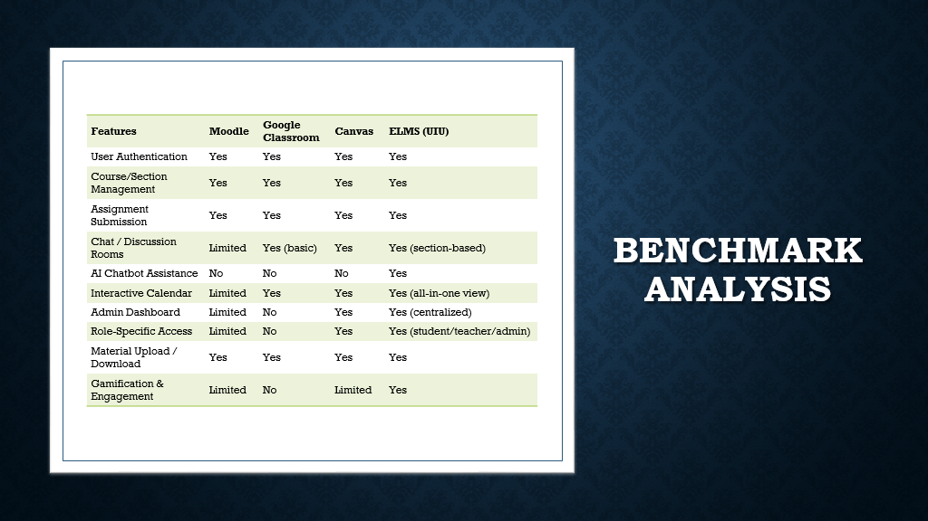

Kindly Refer at the end of this document for the whole table.

* 1. **Survey:**

In the pursuit of continuous improvement and customer-centric product development, we conducted a Customer Satisfaction Survey to gauge the sentiment and feedback of our valued customers regarding our latest product. The survey aimed to identify areas for improvement, and understand how our product will align with customer expectations.

### 3.3.1 Survey Methodology

1. **Survey Type**: Online questionnaire.

1. **Sample Size:** 9 respondents.

**Survey Questions:**

1. Do you currently use a Learning Management System (LMS) like Moodle, Canvas, or Blackboard for your courses?
2. Which Learning Management System do you use most frequently?
3. What do you primarily use the LMS for? (e.g., accessing materials, submitting assignments, checking grades, viewing calendar)
4. How satisfied are you with the current Learning Management System you use?
5. What are the biggest challenges or frustrations you face when using your current LMS? (e.g., hard to find materials, confusing assignment submission, no feedback, etc.)
6. How interested are you in a new LMS that includes an AI Learning Assistant for personalized help and better real-time features?
7. How important is the ability to easily resubmit an assignment after receiving feedback from your teacher?
8. How useful would a real-time chat feature to quickly message your teachers or classmates for academic help be to you?
9. How valuable would an AI Learning Assistant (powered by AI) be for getting instant, personalized help with your course materials and assignments?
10. Please select all the features you would like to see in a new LMS:
    * Easy and clear course enrollment process
    * A simple way to submit and re-submit assignments
    * A clear view of your grades and teacher feedback
    * A personal calendar that automatically shows your assignments and deadlines
    * An AI Learning Assistant for 24/7 personalized study help
    * Reliable notifications for new grades, deadlines, and announcements
    * A powerful search to find specific files, assignments, or information across all your courses
    * Support for all common file types (PDF, DOC, PPT, Video) for course materials
    * Real-time chat with teachers and classmates
11. What is one additional feature you wish your ideal Learning Management System had?

**3.3.2 Survey Results and Analysis:**

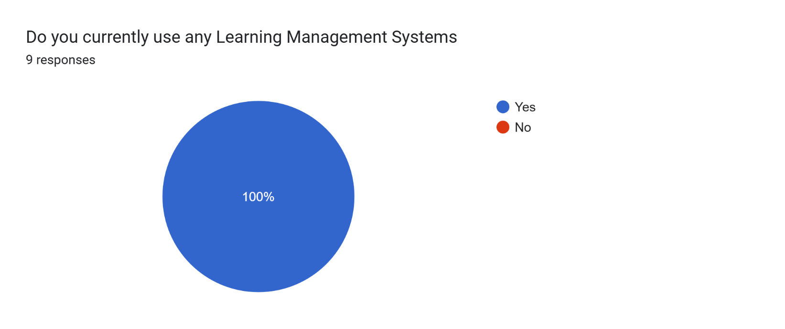

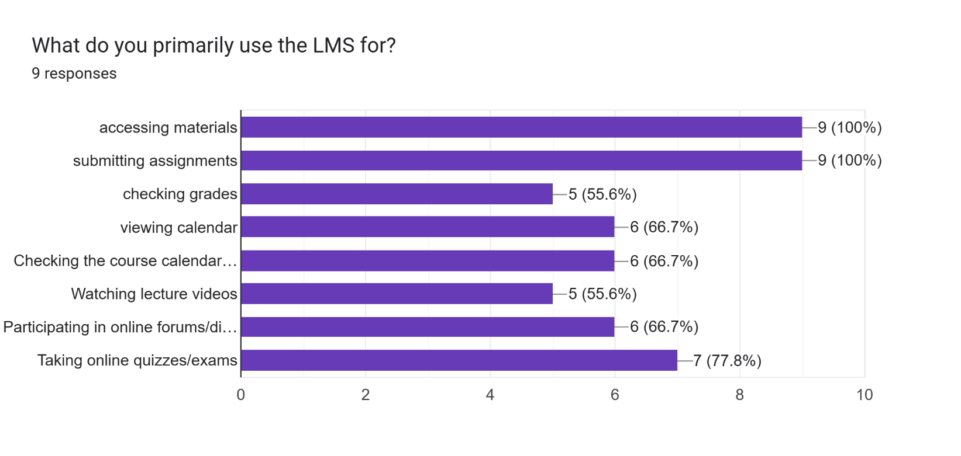

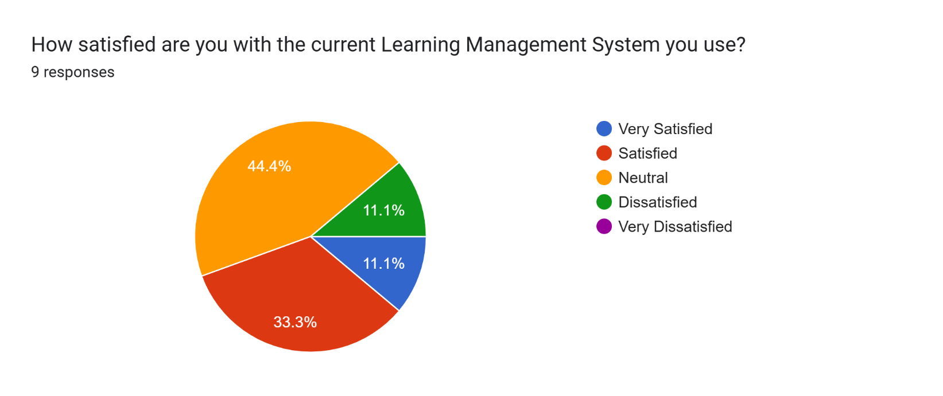

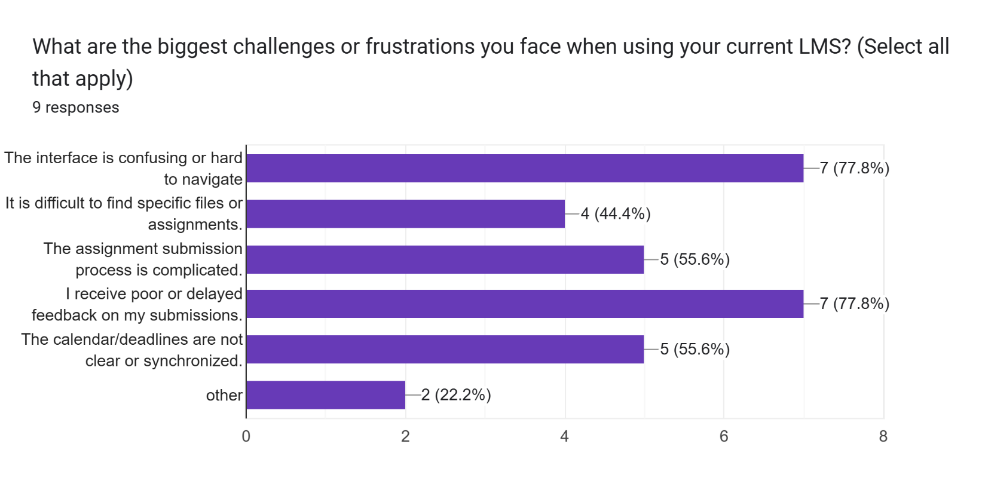

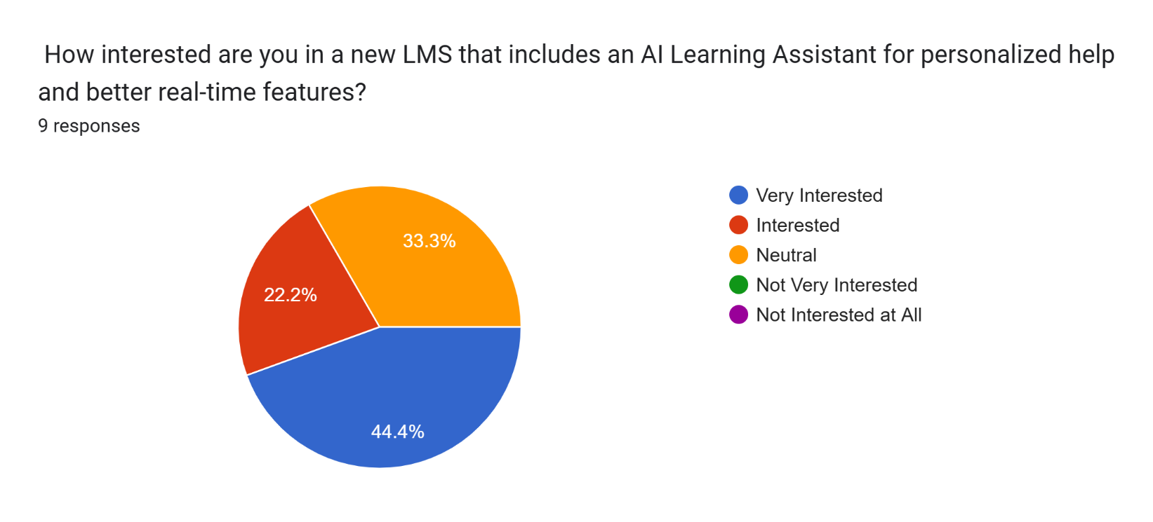

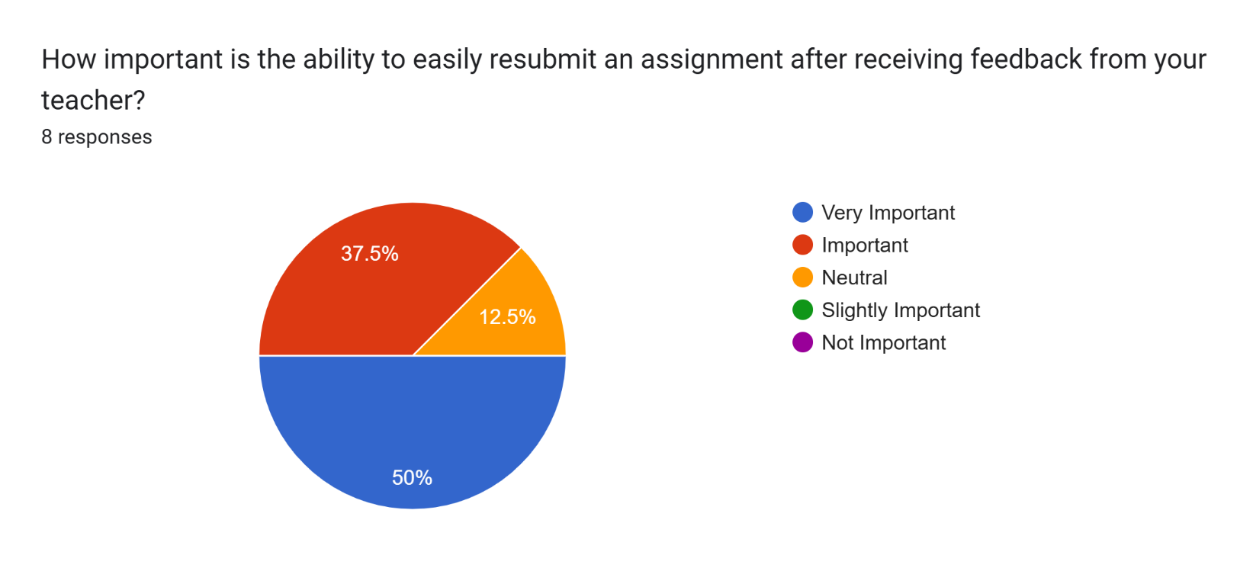

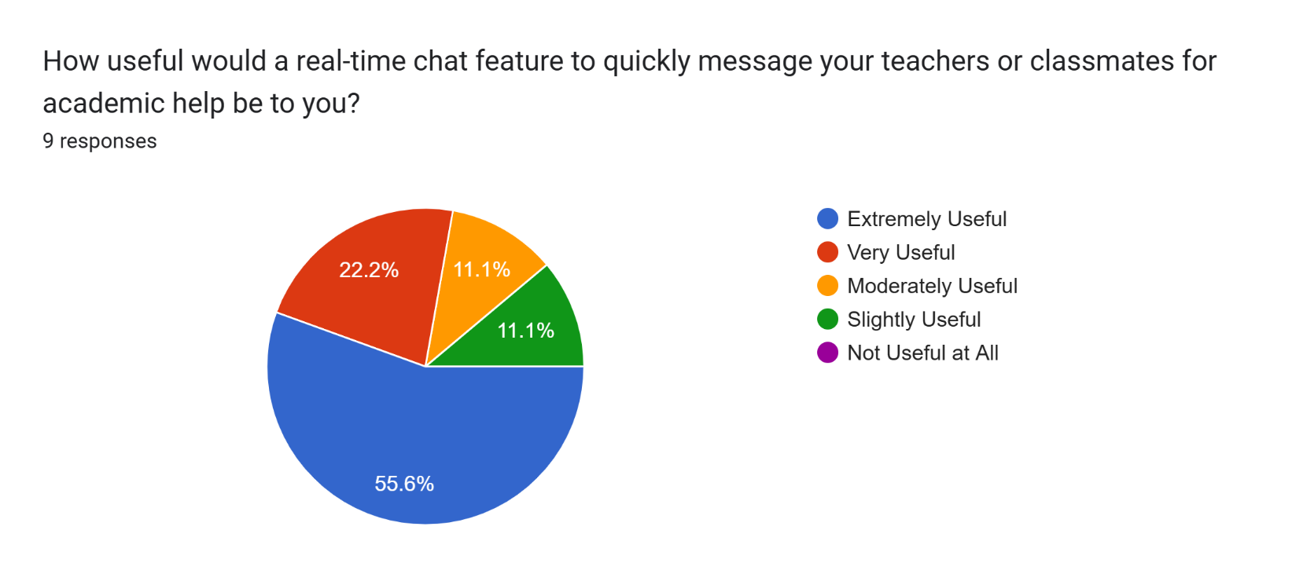

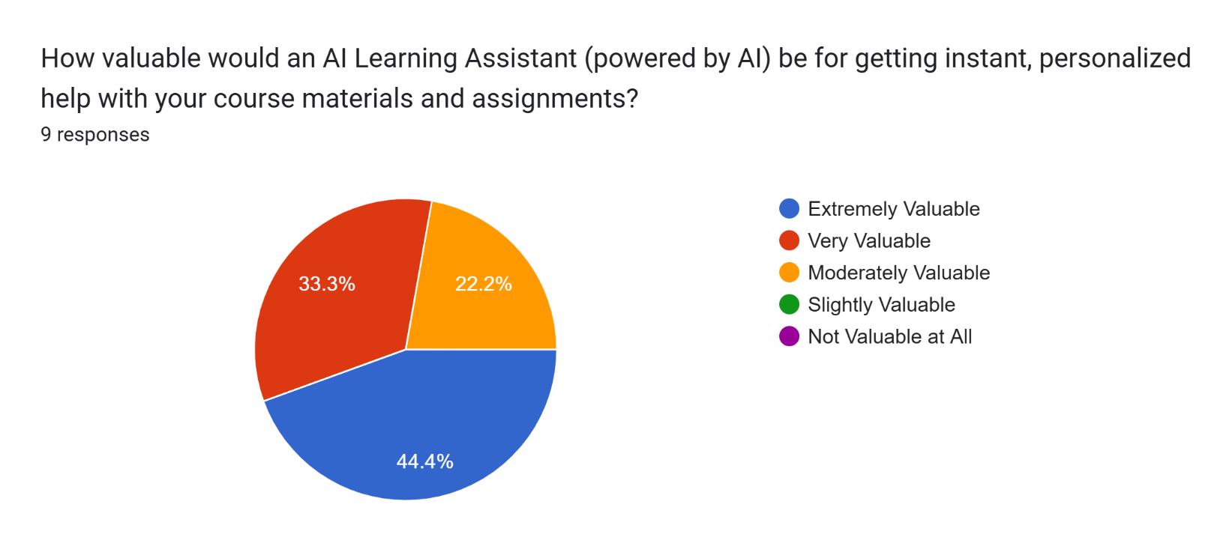

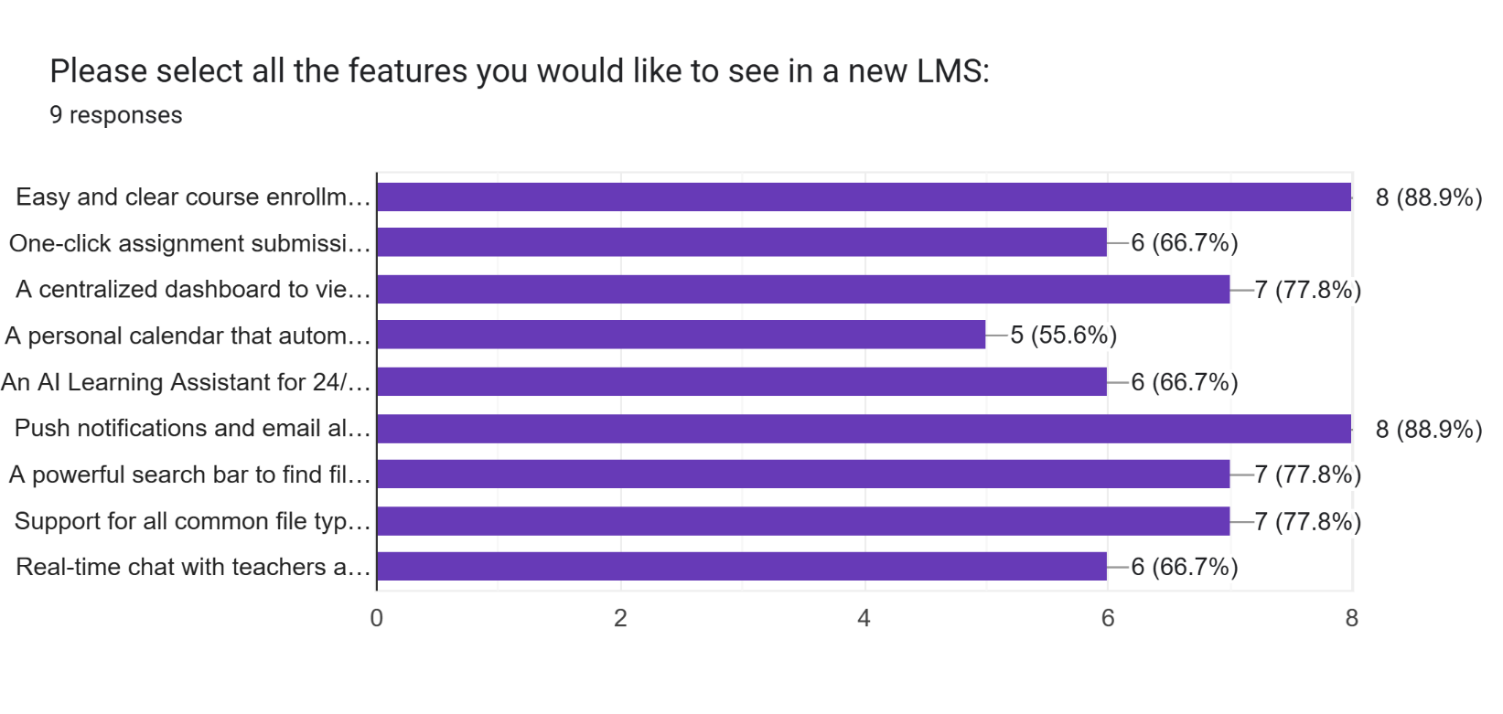

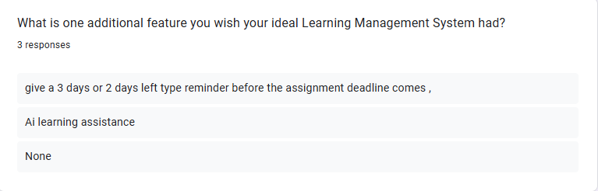

### 3.3.3 Some Reviews On Our Survey

**Review 01**

|  |  |  |  |
| --- | --- | --- | --- |
| The idea of a campus-only food app is great, but please make sure the interface is simple and not cluttered. I love the idea | | | |
| of rewards—maybe offer discounts or free items after a certain number of orders. Also, a leaderboard for top food | | |  |
| reviewers or most active users would make it more fun and competitive. Best of luck! | |  |
| **Review 02** |  |

Most of us don’t track canteen prices or meal choices properly. An app like this could really help students budget better. Maybe add a feature to compare prices between canteens or track monthly food expenses. That would be super useful.

**Review 03**

The app focus on affordability,fast delivery features like real time order tracking and student delivary riders make it more trustworthy, if you can include meal plan integration and eco friendly it would be a complete solution for uiu.

**3.4 SWOT ANALYSIS**

## ELMS- All in One Software for Studies related management

## SWOT Analysis

### Strengths

**Skilled & Balanced Team**

* **Frontend Expertise:** Our team is proficient in **HTML, CSS, Bootstrap, PHP, JavaScript, and jQuery**, ensuring a clean, responsive, and accessible interface for students, teachers, and admins.
* **Backend Proficiency:** Using **PHP and MySQL**, the system ensures secure data handling, efficient performance, and scalability.
* **Project Leadership:** Agile project management enables structured sprints, on-time delivery, and regular user feedback integration for continuous improvement.

**Academic-Centric Design**

* **Campus-Exclusive System:** ELMS is custom-built for **UIU students, teachers, and administrators**, ensuring it aligns with academic policies and workflows.
* **Role-Based Functionality:** Separate dashboards for **students, teachers, and admins** provide clarity, focus, and easy navigation.

**Feature Integration**

* **AI-Powered Chatbot:** Offers instant academic and system-related assistance, reducing dependency on manual help.
* **Collaborative Tools:** Chat rooms, calendar events, and assignment tracking create a connected and interactive learning environment.

### Weaknesses

**Technical Complexity**

* Integrating **AI chatbot, chat rooms, and real-time calendar synchronization** demands ongoing maintenance and optimization.
* Cross-browser and cross-device compatibility requires continuous testing.

**Scalability Limitations**

* Current architecture is optimized for **single-campus deployment**; expanding to multiple universities would need significant backend upgrades.

**Adoption Barriers**

* Teachers and students may resist transitioning from familiar systems like **Google Classroom or Moodle** without strong incentives.
* Initial training or orientation may be required for smooth adoption.

**Resource Dependency**

* Server reliability and consistent internet connectivity are critical for smooth operations and data synchronization.

### Opportunities

**Untapped Academic Market**

* No existing system at UIU offers a **unified platform** combining content delivery, section-based collaboration, AI chat, and admin tools.
* Potential to become UIU’s official **centralized learning and communication platform**.

**University Integration**

* Future expansion to include **student ID integration**, **attendance tracking**, and **exam scheduling** under one system.
* Possible **integration with other UIU platforms**, such as result management or admission systems.

**AI & Analytics Expansion**

* Implement **AI-based grading assistance**, **personalized learning recommendations**, and **performance analytics dashboards** for teachers.

**Monetization & Growth**

* Develop mobile versions (Android/iOS) for broader accessibility.
* Offer licensing opportunities to other universities once the system matures.

### Threats

**Competitive LMS Platforms**

* Established platforms like **Moodle, Canvas, and Blackboard** already hold significant market trust and advanced functionalities.

**Operational Risks**

* **Server downtime**, data corruption, or delayed updates could affect academic operations and credibility.

**Data Privacy & Security**

* Must comply with **educational data regulations** (e.g., student records, grades, and personal information).
* Any breach could damage trust and user confidence.

**Institutional Resistance**

* Administrative or faculty hesitation to adopt new systems could slow deployment and system-wide integration.

### Short-Term Strategy:

* Launch a **pilot version** with selected departments.
* Focus on key differentiators like **AI chatbot**, **section-based chatrooms**, and **calendar-based assignment tracking**.
* Collect continuous feedback to refine user experience and fix navigation challenges.

### Long-Term Strategy:

* **Expand** to other faculties or universities under UIU’s academic network.
* Integrate **AI analytics** for personalized learning paths and performance tracking.
* Partner with **academic clubs and departments** for awareness, training, and user engagement initiatives.
* Maintain a **sustainable roadmap** with periodic updates and green digital practices (e.g., paperless submissions).

## Chapter - 4: Design of the System

### 4.1 Introduction

This chapter presents the architectural design of the **ELMS (Efficient Lunch Management System)**, translating the project’s conceptual goals into a well-structured, scalable, and user-focused system. The design serves as a blueprint connecting user requirements identified through surveys and gap analysis to the system’s technical execution.

The objective of this phase is to ensure:

* **Seamless User Experience:** Simple and intuitive interface for browsing, ordering, and tracking meals.
* **Efficient Data Flow:** Smooth interaction between students, canteens, delivery personnel, and the admin.
* **Scalability and Maintainability:** Support for future expansion across multiple university campuses.

The system design includes various diagrams (such as context, DFD, and use case diagrams) representing both **functional and non-functional** requirements. These ensure that every component—from menu display to order delivery—is interconnected to deliver a reliable and efficient food ordering experience within UIU.

**4.2 Context Diagram**

The **Context Diagram** illustrates the ELMS system as a central entity and defines its interactions with external actors. It provides a high-level overview of how data moves between the system and its external entities, clearly showing system boundaries and relationships.

**External Entities:**

* **Students (Users):** Browse menus, place orders, make payments, and rate canteens.
* **UIU Canteens (Vendors):** Update menu items, confirm orders, and manage stock and pricing.
* **Delivery Personnel (Students):** Receive assigned deliveries, update order status, and complete deliveries.
* **Admin:** Monitors system activity, manages users, reviews ratings, and ensures service quality.
* **Payment Gateways:** Facilitate financial transactions through **Cash on Delivery (COD)** and **Digital Wallets**.

**System Functions:**

* **User Authentication:** Secure login for students, canteens, and admin.
* **Menu & Search Management:** Real-time menu browsing, category filtering, and keyword-based search.
* **Order Management:** Handles cart operations, order placement, tracking, and completion.
* **Payment System:** Integrates COD and digital wallet transactions.
* **Delivery Module:** Assigns and tracks delivery personnel for each order.
* **Admin Dashboard:** Centralized monitoring for analytics, performance reports, and issue management.
* **Notification System:** Sends updates on order confirmations, payments, and delivery status.

**Context Diagram**:

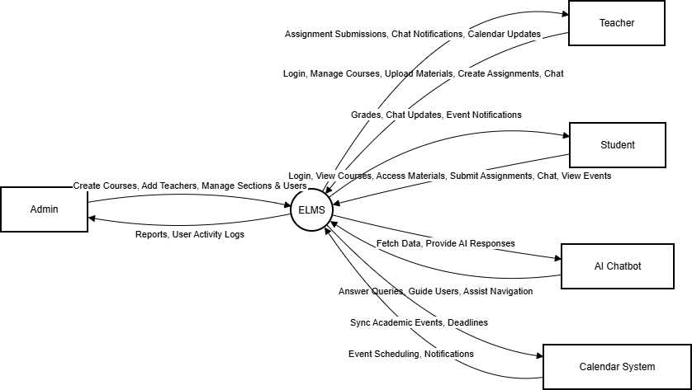

### 4.3 Use-Case Diagram

A Use-Case Diagram depicts the interactions between users and the system. It helps to understand the high-level functionality of the system.

**Actors:**

* Student/Staff (Primary user)
* Canteen Vendor (Food provider)
* Delivery Personnel (Student rider) ● Admin (UIU management) ● **Use Cases:**

○ Select Food Category

○ Search Food Items

○ Track Order Status

○ Filter Food by Price and Vendor

○ Add to Cart & Checkout

○ Payment Gateway

**4.3.1 USE CASE Description:**

**Use-Case ID: UC-001**

**Use-Case Name: User Authentication**

**Primary Actor: Student / Teacher / Admin**  
 **Secondary Actors: None**

**Description:**  
 **This use case enables registered users (students, teachers, and administrators) to securely log in and access their personalized dashboards based on assigned roles.**

**Preconditions:**

* **The user has a valid account in the ELMS database.**
* **The system is online and accessible.**

**Success Scenario:**

1. **The user navigates to the login page.**
2. **The system prompts for username and password.**
3. **The user enters valid credentials and clicks “Login.”**
4. **The system verifies credentials and identifies user role.**
5. **The user is redirected to their respective dashboard (Admin / Teacher / Student).**

**Alternative Scenarios:**

* **Invalid Credentials:**
  + ***Issue:* Username or password is incorrect.**
  + ***Solution:* System displays an error message and prompts retry.**
* **Account Locked:**
  + ***Issue:* Multiple failed login attempts.**
  + ***Solution:* System temporarily locks account and notifies admin.**

**Post Conditions:**

* **User is authenticated and role-specific session is created.**
* **Dashboard and accessible modules are displayed.**

**Use-Case ID: UC-002**

**Use-Case Name: Course and Section Management**

**Primary Actor: Admin**  
 **Secondary Actors: Teacher**

**Description:**  
 **This use case allows the Admin to create and manage courses, assign teachers to sections, and enroll students into specific sections.**

**Preconditions:**

* **Admin is logged into the system.**
* **The database structure for courses and sections is initialized.**

**Success Scenario:**

1. **Admin navigates to the “Manage Courses” module.**
2. **Admin clicks “Create Course” and inputs course name, code, and description.**
3. **Admin creates sections and assigns teachers.**
4. **The system stores the data and notifies assigned teachers.**

**Alternative Scenarios:**

* **Duplicate Course Code:**
  + ***Solution:* System prevents duplication and prompts for a unique code.**
* **Teacher Not Available:**
  + ***Solution:* Admin receives a message to assign a different teacher.**

**Post Conditions:**

* **Course and section information are successfully stored.**
* **Teachers and students can view their assigned sections.**

**Use-Case ID: UC-003**

**Use-Case Name: Upload and Access Course Materials**

**Primary Actor: Teacher**  
 **Secondary Actors: Student**

**Description:**  
 **This use case allows teachers to upload course materials (PDF, DOCX, PPT) for students to view or download within their section.**

**Preconditions:**

* **Teacher is logged in and assigned to a course.**
* **The file upload system is functional.**

**Success Scenario:**

1. **Teacher navigates to a specific course.**
2. **Teacher uploads course materials (notes, slides, etc.).**
3. **System stores the file and associates it with the course.**
4. **Students enrolled in that section can access and download the materials.**

**Alternative Scenarios:**

* **Invalid File Format:**
  + ***Solution:* System notifies teacher and allows re-upload with supported file types.**
* **Upload Error:**
  + ***Solution:* System logs error and suggests retry.**

**Post Conditions:**

* **Files are successfully uploaded and accessible to enrolled students.**

**Use-Case ID: UC-004**

**Use-Case Name: Assignment Submission**

**Primary Actor: Student**  
 **Secondary Actors: Teacher**

**Description:**  
 **This use case allows students to upload assignments within a set deadline and teachers to review submissions.**

**Preconditions:**

* **Student is logged into the system.**
* **The teacher has created an assignment for the course.**

**Success Scenario:**

1. **Student navigates to the assignment section.**
2. **Student uploads the assignment file.**
3. **System records submission timestamp.**
4. **Teacher can later download and review submitted assignments.**

**Alternative Scenarios:**

* **Late Submission:**
  + ***Solution:* System marks as “Late” or blocks submission after deadline.**
* **File Not Uploaded Properly:**
  + ***Solution:* System prompts retry with upload progress feedback.**

**Post Conditions:**

* **Assignment submission is recorded in the database.**
* **Teacher receives notification for new submission.**

**Use-Case ID: UC-005**

**Use-Case Name: Chatroom Communication**

**Primary Actor: Student / Teacher**  
 **Secondary Actors: None**

**Description:**  
 **This use case enables students and teachers in the same section to communicate via an integrated real-time chatroom.**

**Preconditions:**

* **User is logged in and part of a valid section.**
* **Chatroom service is active.**

**Success Scenario:**

1. **User navigates to the section’s chatroom.**
2. **User sends a message or attachment.**
3. **System displays the message in real-time to all participants in the section.**

**Alternative Scenarios:**

* **Server Disconnection:**
  + ***Solution:* System displays “Reconnecting…” and retries connection.**
* **Inappropriate Message:**
  + ***Solution:* Admin/Teacher can moderate or remove messages.**

**Post Conditions:**

* **Message is visible to all section members.**
* **Chat logs are stored securely in the database.**

**Use-Case ID: UC-006**

**Use-Case Name: Calendar and Event Management**

**Primary Actor: Teacher / Admin**  
 **Secondary Actors: Student**

**Description:**  
 **This use case allows teachers or admins to create, edit, and publish academic events such as exams, deadlines, or class activities.**

**Preconditions:**

* **User (teacher/admin) is logged in.**
* **Calendar module is active.**

**Success Scenario:**

1. **Teacher/Admin navigates to “Calendar.”**
2. **Creates a new event with title, date, and description.**
3. **System saves the event and notifies relevant students.**

**Alternative Scenarios:**

* **Date Conflict:**
  + ***Solution:* System alerts user about overlapping events.**

**Post Conditions:**

* **Event is stored and visible in the calendar for all associated users.**

**Use-Case ID: UC-007**

**Use-Case Name: AI Chatbot Assistance**

**Primary Actor: Student / Teacher / Admin**  
 **Secondary Actors: None**

**Description:**  
 **This use case enables users to interact with the integrated AI chatbot for navigation support, academic queries, or system guidance.**

**Preconditions:**

* **User is logged in.**
* **AI chatbot service is active.**

**Success Scenario:**

1. **User opens the chatbot panel.**
2. **User types a query (e.g., “How to submit assignment?”).**
3. **AI chatbot retrieves information and displays a helpful response.**

**Alternative Scenarios:**

* **Unrecognized Query:**
  + ***Solution:* Chatbot responds with “I’m not sure” and suggests contacting admin.**

**Post Conditions:**

* **Chatbot interaction is logged for improvement and analytics.**